Stanground Standard
Project Restart: How realistic is Premier League plan to resume season?
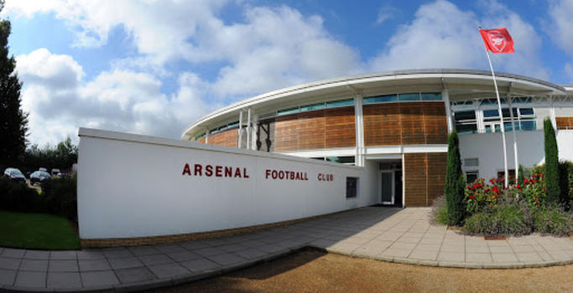  Arsenal who opened the training ground this week to players  https://www.bbc.co.uk/sport/football/52443200  When Premier League club executives link up for a crucial video conference call on Friday they will do so amid unprecedented pressure, and mounting unease.  The tension surrounds not only how the plan to resume the football season behind closed doors at a small number of sealed and approved venues should develop, but whether it is realistic, responsible or indeed appropriate to pursue it at all. The sense is that hopes of a return to action by early June now hang by a thread. Confidence has undoubtedly been shaken by the French government's decision to put elite sport on hold until September, along with the warnings of medical experts and player representatives about the health risks of rushing back into action.  Some clubs are worried the sporting integrity of the competition could be compromised if only certain venues are used and they play fewer games at their home ground than their rivals. Others say they feel pressured into agreeing to play by politicians and league bosses when they would prefer the season to be abandoned. | 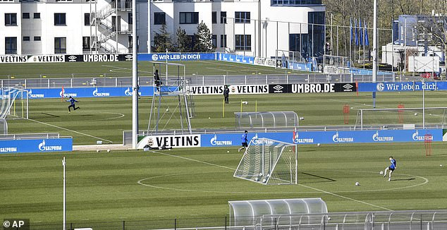  Schalke who returned to training following social distancing  Crucial video conference call on Friday they will do so amid unprecedented pressure, and mounting unease.
 | Privately, the mood within both the Premier League and in Whitehall suggests cautious optimism remains. And there are some reasons for positivity too. Political leaders in Switzerland, for instance, have announced that the country's Super League will "probably" resume on 8 June if there's no worsening of the outbreak. Uefa's medical chief Professor Tim Meyer, meanwhile, has said it is "definitely possible" to plan for the suspended 2019-20 season to restart. Read into that what you will. But by the time Friday's Premier League meeting takes place, is there a real danger that Project Restart could have suffered a false start? The clubs know that, ultimately, they will take their lead from government, and their medical and scientific experts. That was proved by what happened across the Channel, where the French league's modelling and scenario planning was suddenly rendered meaningless when Prime Minister Edouard Philippe made his shock announcement, and the season was abruptly cancelled, as it has been in the Netherlands and Belgium. | Government approval in the UK relies on key criteria such as improved testing capacity, and a relaxation of social distancing rules being met. But ministers and their advisers will also be hanging on Angela Merkel's every word on Thursday when the German chancellor addresses regional leaders, and no doubt discusses the Bundesliga's plans to resume matches in mid-May - plans that have acted as a source of inspiration to other countries around Europe. But with a recent spike in cases in Germany raising fears that their lockdown may be tightened again, if Merkel follows the French in ruling sport out for several months, some believe the game could be up for the Premier League too. How realistic would it be, after all, that Germany, which has suffered far fewer cases and deaths from coronavirus than the UK, and has conducted many more tests, could deem sport too dangerous, but that conclusion not be reached here?  Let us not forget that Wednesday's government briefing brought the news of another 765 deaths in the UK.
IN THIS ISSUE
Captain Tom Moore Birthday – Page Two | ON THIS DAY SPORTING EVENT -PAGE THREE | bORN ON THIS DAY-paGE five

rugby union  Wayne Pivac aware Wales may be unable to play at Principality Stadium on return  The stadium in Cardiff is currently a field hospital. |  |  |  |  |  |  |  | Captain Tom Moore  Captain Tom Moore: Cricket and F1 stars send 100th birthday wishes  https://www.skysports.com/more-sports/news/12040/11980833/captain-tom-moore-cricket-and-f1-stars-send-100th-birthday-wishes  Captain Tom raised more than £29m for the NHS after walking 100 lengths of his back garden. Sports stars have wished Captain Tom Moore a happy birthday as the war veteran and fundraising hero turns 100. Captain Moore raised more than £29m for the NHS following a challenge he set to walk 100 lengths of his back garden before his birthday. He completed the challenge on April 16 and has become an inspirational figure since. He has even shot to the top of Britain's music charts with a rendition of the sporting anthem You'll Never Walk Alone. 'Captain Tom', who is an avid cricket and motor racing fan, will receive a telegram from the queen and special birthday wishes from the nation including from cricket and Formula One stars. England Test captain Joe Root said: "Captain Tom Moore, I just want to wish you a very happy birthday. The amount of money is just staggering. It's phenomenal and you are a credit to this nation." Ben Stokes said: "I hope I am moving just as well as you at 50 never mind 100. Keep up all the great work mate and you should be seriously proud of what you have done. Brilliant." James Anderson said: "You really are an inspiration to everyone. I also want to wish you a very happy 100th birthday." England women's team captain Heather Knight said: "Thank you so much for the amazing thing you have done for the NHS and inspiring this country. You have shown what it is all about to be British and you should be very proud." Stuart Broad, Jos Buttler and Jonny Bairstow also left messages for the centurion in the video above, while the England and Wales Cricket Board has confirmed that Captain Moore will be invited to address the men's team at a future Test. An ECB spokesperson confirmed: "The England cricket teams are in awe of him, his humility and the unprecedented fundraising he has achieved over the past few weeks. "Once cricket returns and spectators can watch the England teams play again, we will formally invite Captain Tom to come and meet the team and be our honorary guest. "The England Test captain Joe Root has confirmed directly with Captain Moore and his family that he can address the team personally in the dressing room before a Test match. It would be one of the greatest honours bestowed on the team to hear directly from him. We cannot wait for that day." F1 drivers, team principals and administrators all sent tributes; Valtteri Bottas, Carlos Sainz Jr, Lance Stroll and Christian Horner among them.  On this day – Sporting event  Death of Ayrton Senna https://en.wikipedia.org/wiki/Death_of_Ayrton_Senna  On 1 May 1994, Brazilian Formula One driver Ayrton Senna was killed after his car crashed into a concrete barrier while he was leading the 1994 San Marino Grand Prix at the Autodromo Enzo e Dino Ferrari in Italy. The previous day, Austrian driver Roland Ratzenberger had died when his car crashed during qualification for the race. His and Senna's crashes were the worst of several that took place that weekend and were the first fatal collisions to occur during a Formula One race meeting in twelve years. They became a turning point in the safety of Formula One, prompting the implementation of new safety measures in both Formula One and the circuit, as well as the Grand Prix Drivers' Association to be reestablished. The Supreme Court of Cassation of Italy ruled that mechanical failure was the cause of the crash, although this has been disputed. At the start of the race, Pedro Lamy and JJ Lehto were involved in a serious collision, spraying debris into the crowd and injuring bystanders. Track officials deployed the Opel Vectra safety car, driven by Max Angelelli, to slow down the field and allow the removal of debris. The competitors proceeded behind the safety car for five laps. As the Vectra was based on a family sedan and not relatively fast, Senna had pulled alongside the Vectra to gesture to its driver to speed up; this car was subsequently regarded as inadequate for the role (due to the fact that its brakes had overheated and thus had to be driven slowly, lest itself be the cause of a crash) and a cause of the alleged drop in tyre pressures of the following Formula One cars. Before the sixth lap, David Brown told Senna via pit-to-car radio that the safety car was pulling off, and Senna acknowledged the message. On lap 6, the race resumed and Senna immediately set a quick pace with the third-quickest lap of the race, followed by Schumacher. At the flat-out left-hander Tamburello corner. On lap 7, the second lap at racing speed, Senna's car left the racing line at Tamburello, ran in a straight line off the track and struck an unprotected concrete barrier. Telemetry data recovered from the wreckage shows he entered the corner at 309 km/h (192 mph) and then braked hard, downshifting twice to slow down before impacting the wall at 211 km/h (131 mph). The car hit the wall at a shallow angle, tearing off the right front wheel and nose cone before spinning to a halt.
https://www.bt.com/sport/news/wayne-pivac-aware-wales-may-be-unable-to-play-at-principality-stadium-on-return  Head coach Wayne Pivac concedes Wales may still be unable to play at the Principality Stadium when they return to action. The stadium in Cardiff is currently a field hospital, which was opened on April 20 to meet the increased demand for beds during the coronavirus pandemic. Wales remain on lockdown after rugby was halted in March with one full round of the Six Nations to play. There is no timeframe to return and Pivac admitted the side could be left without a venue. “It’ll be nice when we get back there but it’s the sort of thing you have to work from scenario a or scenario b,” he said. “One would be getting back to play at the stadium, if available, and the hospital could be there if there was a second wave of the virus. “We’re not sure of the timings and we’re all up in the air, it’ll be a special day when we do get back. “It’s mind blowing to think a number of weeks ago we were training at the Principality and now they are set up as a hospital. It shows the amazing work by people to make it happen in a short time. “It puts it into perspective and rams home the enormity of what we’re dealing with. It is a unique time and it’s amazing to see what has happened in a short space of time.”Wales are scheduled to visit New Zealand for two Tests in July after a one-off clash in Japan on 27 June. | 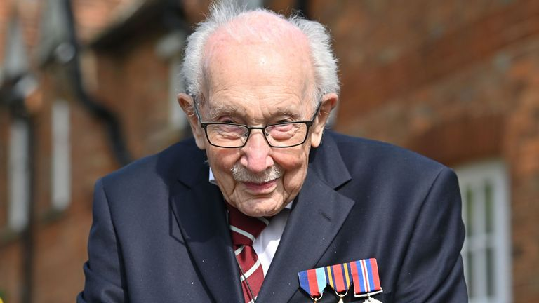  Captain Tom Moore has raised more than £29m for the NHS  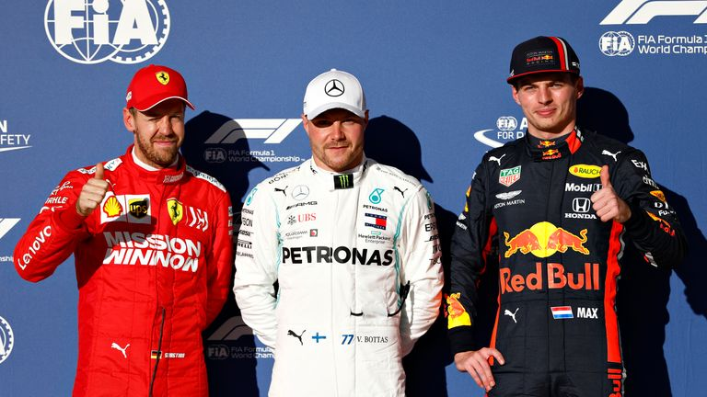  Bottas (middle) led tributes from F1 drivers. Below Wales Head coach Wayne Pivac  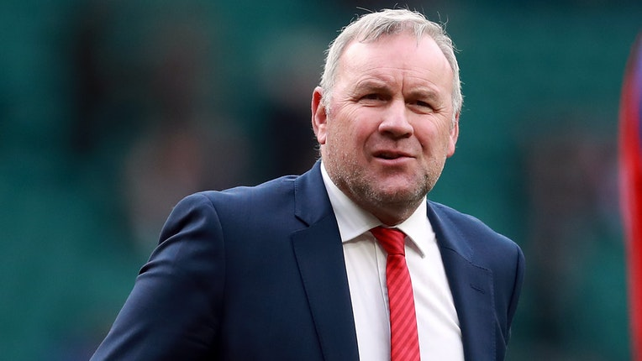
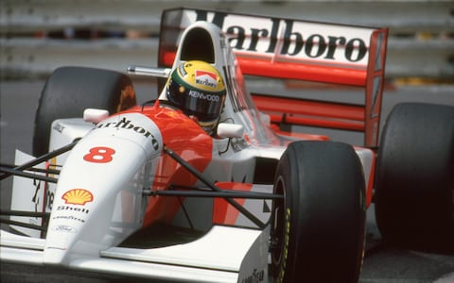
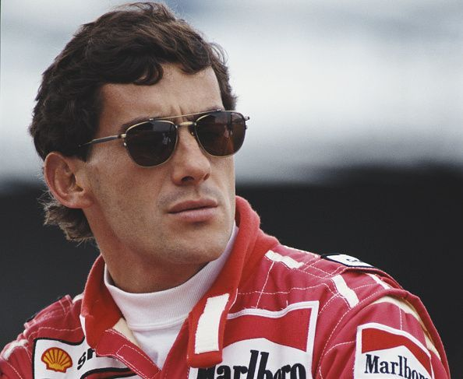
Virus impact

Andrew Cole: Ex-Manchester United & Newcastle striker says 'no day comes easy' https://www.bbc.co.uk/sport/football/52484923
Former Manchester United, Newcastle and England striker Andrew Cole has opened up about his "daily grind" in shielding from the coronavirus pandemic. Cole is one of over a million people more vulnerable to the virus after having a kidney transplant in 2017.The 48-year-old told BBC Radio 5 Live that "no day comes easy" as he continues to self-isolate alone.  "It's a difficult period but it's just a case of getting your head down and doing what you can," he said."You don't know how you're going to feel, and there are good days and bad days. "It's a total lack of energy and you question yourself on what you did the day before, but you cannot come up with an answer because you did nothing yesterday to make you feel like you do today. |  | "Mentally, that is when it starts to get to you a bit." Cole, who won 15 England caps, also played for Arsenal, Fulham, Bristol City, Blackburn, Manchester City, Portsmouth, Birmingham, Sunderland, Burnley and Nottingham Forest in a 19-year career. He remains the third highest scorer in Premier League history with 187 goals, winning five league titles, two FA Cups and the 1999 Champions League with Manchester United, and a League Cup with Blackburn. Cole suffered kidney failure in 2015 after contracting an airborne virus, and now says a lack of human interaction is one of the "toughest challenges". "The first couple of weeks were not bad but the last month or so has been really difficult due to the fact you're not allowed to go out," he added |  |  |  |  | "You can talk on the phone or on Zoom, but ultimately, the difficult part has been not being able to interact with people." I've been by myself and I think we will all spend more times with friends and family after this because you just don't know what's going to happen in the world nowadays." The former striker has set up the Andy Cole Fund to raise money for kidney research, but he says raising awareness of the illness is more important than the funds." People do not understand how difficult an illness this is," he said." People ask me if I'm OK because I look really well, but I try and explain to them that I'm never going to be OK." However you look on the outside is not how you feel on the inside."
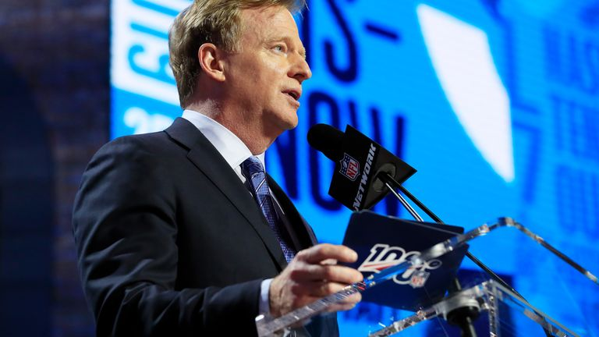  NFL commissioner Roger Goodell makes more than £24m a year |  |  |  | nfl  NFL commissioner Roger Goodell has reduced his salary to $0 due to coronavirus crisis  https://www.skysports.com/nfl/news/12118/11980761/nfl-commissioner-roger-goodell-has-reduced-his-salary-to-0-due-to-coronavirus-crisis  NFL commissioner Roger Goodell has reduced his salary to $0 and other league employees will be taking pay cuts or furloughs due to the coronavirus pandemic. Goodell, who makes upward of $30m (£24.1m) a year from salaries and bonuses, voluntarily had his salary reduced this month. The league is also implementing tiered reductions in base salary, beginning with the pay period ending May 22. The reduction will be five per cent for workers up to the manager's level, seven per cent for directors, 10 per cent for vice presidents, 12 per cent for senior vice presidents, and 15 per cent for executive vice presidents.
football

Tottenham: Harry Kane has recovered from hamstring injury, says Jose Mourinho https://www.bbc.co.uk/sport/football/52487767
Tottenham striker Harry Kane has recovered from his hamstring injury, says Spurs manager Jose Mourinho.  Kane had surgery to resolve the problem on 1 January and is fit again, along with team-mates Moussa Sissoko and Steven Bergwijn."It is one thing not to be injured, it's another thing to be ready to play football," Mourinho told Sky Sports. "For them it is many, many, many weeks of injury and when the injuries were almost at an end, we stopped training." The Premier League has been suspended since 13 March because of the coronavirus pandemic but it is hoped there will be a return to action on 8 June, which would require full training to begin by 18 May. Tottenham have made a limited number of pitches available for the first-team squad to use for individual training sessions, but Mourinho is |  | unsure whether Kane, midfielder Sissoko and winger Bergwijn will be ready for any resumption. "I don't know, they don't know, we have to wait for the official and right permission for the players to train again in groups to see if they can come back to a normal competition level," said the Portuguese. "So if we play this season, the remaining nine matches, it would be good for every one of us, it would be good for football, it would be good for the Premier League if players of that quality can play the remaining matches." Top-flight clubs will meet on Friday to discuss options for the restart, with any restart planned to be spectator free.  "If we play football behind closed doors I'd like to think that football is never behind closed doors," added Mourinho. “With cameras, it means that millions and millions are watching. |  |  |  |  | So if one day we walk into this empty stadium, it will not be empty, not at all."  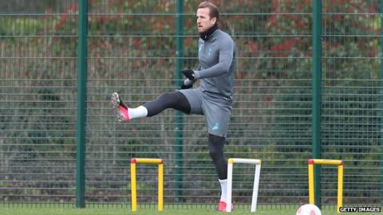
Born on this DAy – gordon Greenidge

An Overview Of The Career Of Gordon Greenidge
https://en.wikipedia.org/wiki/Gordon_Greenidge  Sir Cuthbert Gordon Greenidge KCMG MBE (born 1 May 1951) is a Barbadian former first-class cricketer, who played Tests and One Day Internationals for 17 years for West Indies.  In 2009, Greenidge was inducted into the ICC Cricket Hall of Fame.  Greenidge began his career in English county cricket before he played for Barbados. He played for many seasons with Hampshire in the English County Championship, where he batted as an opener with Barry Richards. He was therefore eligible to play for England until he opted for the West Indies. He later made an appearance for Scotland. During his first-class career, he scored a total of 37,000 runs with 92 centuries. Born in St. Peter, Barbados, Greenidge played as an opening batsman for the West Indies. He began his Test career in 1974 against India at M. Chinnaswamy Stadium, Bangalore. Greenidge and Desmond Haynes formed a prolific opening partnership. The pair made 6,482 runs while batting together in partnerships, the third highest total for a batting partnership in Test cricket history as of 2019.  During the 5th test of the 1983 series between West Indies and India, Greenidge became the first and, as of 2019 only, person in test history to be retired not out. He had to leave the match in Antigua while on 154 to visit his gravely ill daughter, who died two days later, in Barbados.  Greenidge scored two double centuries against England in the 1984 summer Test series. This series was dubbed the "Blackwash" because West Indies won by a margin of 5–0. Greenidge scored 214 not out in the second innings of the second Test at Lord's in June 1984 and followed up with 223 in the fourth Test at Old Trafford in late July. The 214* was achieved on the fifth and last day of the match as West Indies successfully chased 342 for victory. It remains the highest run chase at Lords.  Greenidge became the first player in One Day International (ODI) history to score a century in his 100th ODI when he scored 102* against Pakistan in 1988. In that game he achieved that milestone as captain, with his century eventually going in vain as West Indies lost that match.  In total, Greenidge played in 108 Test matches, scoring 7,558 runs with 19 centuries, and in 128 ODIs, including the 1975 and 1983 World Cup Finals, scoring 5,134 runs and 11 centuries.  Gordon Greenidge decided to pursue a coaching career and became the coach of the Bangladeshi national cricket team in 1996.[9] He was appointed the head coach of the Bangladesh national cricket team in 1997. Under his guidance, the Bangladesh men's cricket team won the 1997 ICC Trophy beating 22 other nations. This also ensured the qualification of Bangladesh to the 1999 ICC Cricket World Cup, which was the first ever appearance in top-level cricket. Participating in their very first cricket world cup changed Bangladesh cricket forever and lead to Test cricket status for the Bangladesh national cricket team in 2000, which meant Bangladesh was promoted to full ICC member status and began playing Test cricket matches. Soon after winning the 1997 ICC Trophy, Gordon Greenidge was conferred honorary citizenship of Bangladesh for these outstanding achievements of winning the 1997 ICC Trophy and simultaneously qualifying for the cricket world cup. Greenidge is currently on the West Indies selection committee for Test matches, along with Viv Richard |  |  |  |  | International information  National side - West Indies (1974-1991)  Test debut (cap 150) 22 November 1974 v India  Last Test 27 April 1991 v Australia  ODI debut (cap 16) 11 June 1975 v Pakistan  Last ODI 25 May 1991 v England  Domestic team information  Years Team  1970–1987 Hampshire  1973–1991 Barbados  1990 Scotland  Career statistics  Competition Test ODI FC LA  Matches 108 128 523 440  Runs scored 7,558 5,134 37,354 16,349  Batting average 44.72 45.03 45.88 40.56  100s/50s 19/34 11/31 92/183 33/94  Top score 226 133* 273* 186*  Balls bowled 26 60 955 286  Wickets 0 1 18 2  Bowling average – 45.00 26.61 105.50  5 wickets in innings – 0 1 0  10 wickets in match – 0 0 0  Best bowling – 1/21 5/49 1/21  Catches/stumpings 96/– 45/– 516/– 172/–  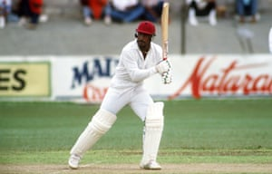
BAsketball

Professional basketball will struggle without government support - BBL chairman https://www.bbc.co.uk/sport/basketball/52480081
Professional basketball in Britain faces a struggle to survive without government support, British Basketball League chairman Sir Rodney Walker says. The BBL and its clubs rely heavily on game-day income rather than broadcast revenue, and the current lockdown has seen their finances all but dry up. Walker says the BBL has taken advantage of the government furloughing scheme but "without the ability to open up and play in front of spectators, we're in a locked-in situation that could become terminal if it went on too long". He added: "I'm not without hope that sufficient progress will be made medically to allow the government to think that they can open up and allow spectators to return, and once that's happened then basketball will be through the crisis, but without the ability to attract spectators, it's going to be a struggle for us. |  | "Sports like Premier League football are blessed with huge amounts of cash behind them both from broadcasters and sponsors. The problem for smaller sports like us and rugby league is very different because [we] don't have those reserves." Walker confirmed the league - along with other sports - has made representations to the Department for Digital, Culture, Media and Sport (DCMS) to secure further support from the government. "We are one of a very small number of sports who do not receive any routine financial support from either Sport England or UK Sport, and it is those sports who are in greatest need," he said. The BBL's showpiece event, the play-off finals, was due to take place in May at the O2 Arena and would have provided a significant source of income for the league. |  |  |  | The loss of fixtures has been also been severely felt by those clubs that own their own venues, such as Leicester, Newcastle and Worcester. And Leicester Riders chairman Kevin Routledge says ensuring the survival of the club will be very challenging. "Having our own venue means we can do so much more in terms of talent development, community work and so on. That's the upside," he said." The downside is when you have literally no money coming in and you still have your overheads - you can't turn the financing requirements off. We are now sitting here with the biggest overheads and with money going out the door at a higher rate than the other clubs." Newcastle Eagles are the league's most successful club having won 25 domestic trophies since 2005, and before the lockdown were regularly attracting crowds of almost 3,000 at their new home and on course for a record-breaking year commercially.
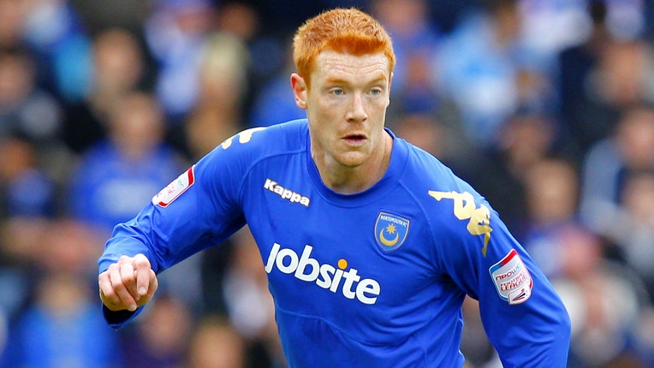  DAVE KITSON: New vision for the PFA. |  |  | ProfessionAL FOOTBALLERS ASSOCIATION  Dave Kitson wants to create a ‘new vision’ for the PFA  https://www.bt.com/sport/news/dave-kitson-wants-to-create-a-new-vision-for-the-pfa Former Reading, Stoke and Portsmouth forward Dave Kitson says he is “ready, willing and able” to lead the Professional Footballers’ Association. The 40-year-old says he has been “troubled” by the criticism of the players’ union from fellow players and the media during the coronavirus pandemic, and that he “can no longer sit idly by and do nothing”. Kitson has posed 101 questions to the PFA leadership and said in a statement: “I have been troubled by the breadth of criticism levelled at the PFA over the past 12 months from both the mainstream media and, in particular in recent months, from a number of esteemed colleagues against whom I’ve either played or otherwise hold in the highest regard. “The recent sharp escalation of public criticism from high-profile players arising out of the PFA’s stated response to the current Covid-19 pandemic is extremely troubling.”
Peterborough Panthers

Peterborough Panthers legend is raring to go again https://www.peterboroughtoday.co.uk/sport/other-sport/peterborough-panthers-legend-raring-go-again-2553042
Panthers legend Ulrich Ostergaard is expected to be back on a bike in full practice within the next few days. The Danish government has set strict rules on riders and mechanics going through their paces – and fellow Dane and Crendon Panthers ace Hans Andersen was on track in Vojens at the weekend. Now Ostergaard, who has been self-isolating in Denmark, is all set to do the same which means he will be riding for the first time in weeks. “ I’m now able to get back on a bike and practice in Denmark,” Ostergaard said. “It’s under very strict guidelines like only one mechanic and you have to change in your van as the clubhouses and changing rooms are all closed. |  | “It’s not ideal, but at least we get the chance to have a skid after not being able to practice anywhere for a while now.” Ostergaard admits the delay to the season has been frustrating – particularly as he was relishing his return to Peterborough. “Everyone at Peterborough was so looking forward to getting the season started and all the team get on well,” Ostergaard added. “Peterborough feels like home for me in England and the team we had put together looks strong. “It’s such a shame we haven’t been able to prove it yet.” It has also been revealed that British Speedway Chairman Rob Godfrey has written to the government committee set up to look at how various |  |  |  | sports can restart. Godfrey has already said the current financial climate rules out racing behind closed doors, but remains hopeful of some sort of season, possibly with one home and one away Premiership league fixtures which would mean 12 in total. Godfrey is also refusing to rule out the prospect of extending a season into November with many riders already hinting they would be happy to do that.  