



Internal Work
Experience Journal
Monday 22 June – Friday 26 June 2026

Name: _______________________________________________________________________________________

Stanground Academy Internal Placement – Year 10

This week you’ll be working with staff across the academy, gaining insight into real job roles and building key employability skills such as teamwork, communication, and organisation.

You are expected to be professional: be punctual, polite, and proactive. Staff will rely on you, so take your tasks seriously and always try your best.

Use this journal to reflect on your experiences and track the skills you develop. By the end of the week, you’ll have a clearer idea of your strengths and future goals.
Make the most of this opportunity—you’re getting a head start in the world of work.

There are five stages to this journal:

Step 1: Preparation is key! Find out your travel time, work wear, and know your safety signs (Week before)

Step 2: Go through the skills builder passport with your employer on the first day and inform them of what they will need to watch out for. Make sure you both understand what is on the form so you can work towards achieving the skills. (First day)

Step 3: Complete your journal, the mini tasks and interview 2 staff members.
(During placement)

Step 4: Share the skills builder page with your employer. Go through the essential skills together on the first day, then review daily and sign off any you have achieved during your placement. (Everyday)

Step 5: Reflect on your experience and log all of the skills you’ve gained.
(End of the week)

Your work experience journey starts here, good luck!

Placements profile

Department you’re working with: _______________________________________

Role title or area: _____________________________

Reporting:

Who are you reporting to during your work experience?

Dates of experience:

Start date: End date:

Working hours:

Start: am/pm End: am/pm daily

Lunchtime arrangements:

Detail below what your lunchtime arrangements will be e.g. packed lunch, lunch provided by employer, buying lunch etc.

Work wear:

Detail below if you are required to wear certain clothing for your role. For example, a suit, high visibility jacket, company clothing etc.

Will this be provided for you?

Travel arrangements:

How will you get to your placement?

How long will this take?

How much will it cost?

Protocols

What do you do if…

You’re ill?

You’re going to be late?

Are you concerned about any aspect of your placement?

Health and safety:

When you start your experience week, you will be informed of any health and safety rules you need to adhere to. You must inform your employer of any medical conditions or health issues you may have, especially if they could affect your ability to undertake certain tasks.

Some safety signs explained:
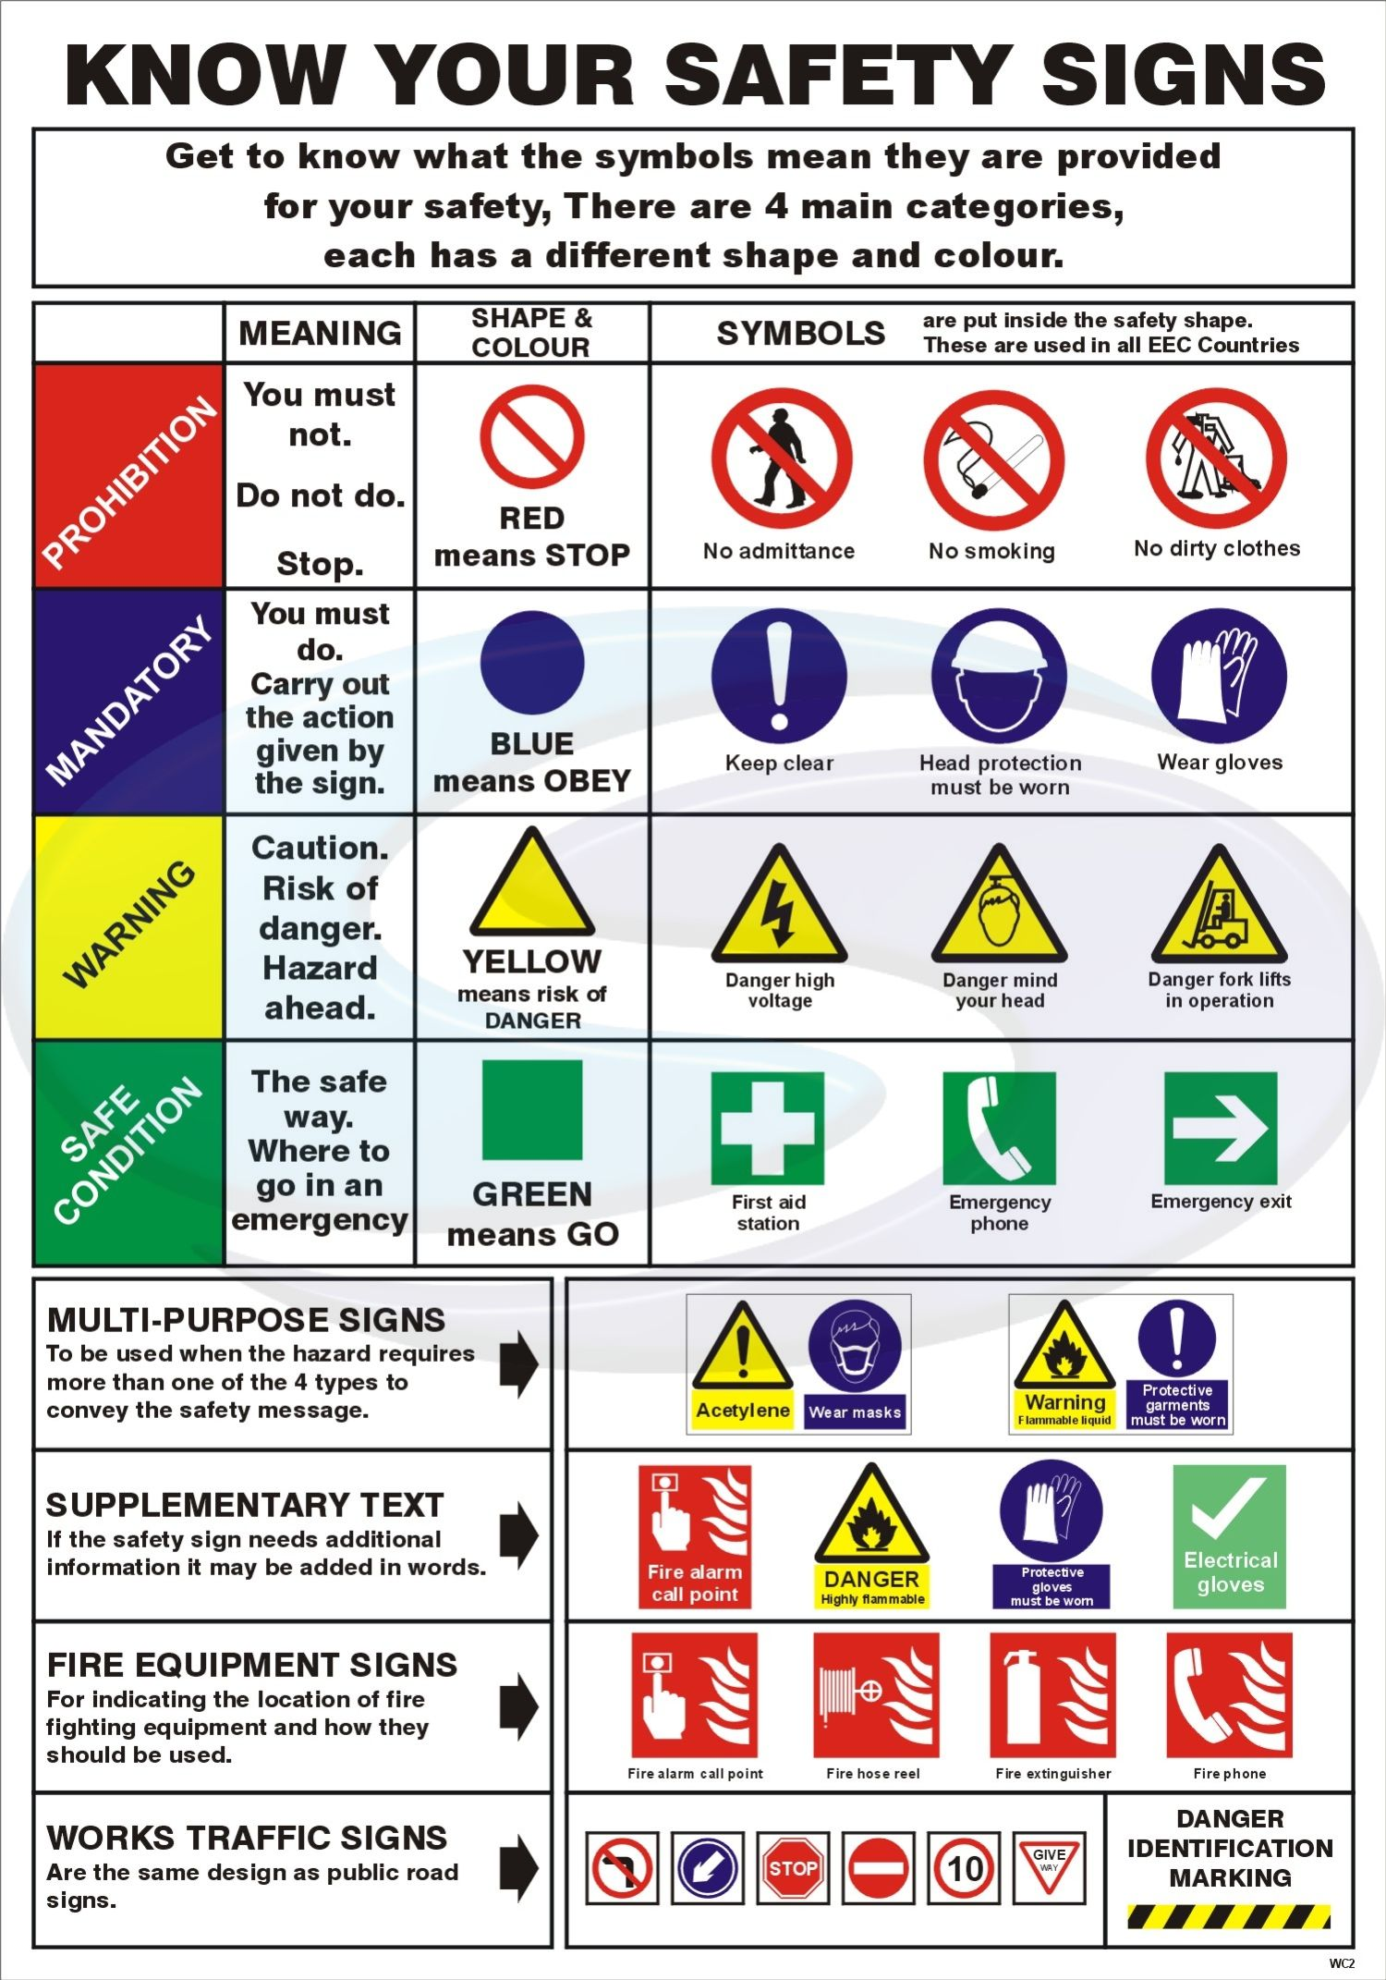

Aims for the Week

Overall, what do you hope to achieve?

What employability skills would you like to gain and improve?

What knowledge you would like to gain?

Which one of your personal strengths do you want to develop further?

Daily Reflection

Monday

Tasks you completed: ________________________________________________________________________________________________________________________________________________________________________________________________________

Staff you worked with: ________________________________________________________________________________________________________________________________________________________________________________________________________

New things you learned: ____________________________________________________________________________________________________________________________________________________________________________________________________________________________________________________________________________________________________________

One skill you practiced today: ________________________________________________________________________________________________________________________________________________________________________________________________________

One challenge and how you responded: ____________________________________________________________________________________________________________________________________________________________________________________________________________________________________________________________________________________________________________

How you felt about your contribution today: ____________________________________________________________________________________________________________________________________________________________________________________________________________________________________________________________________________________________________________

What you’re aiming to do better tomorrow: ____________________________________________________________________________________________________________________________________________________________________________________________________________________________________________________________________________________________________________

Daily Mini Task 1

Interview a staff member about their role and how they got into it
________________________________________________________________________________________________________________________________________________________________________________________________________________________________________________________________________________________________________________________________________________________________________________________________________________________________________________________________________________________________________________________________________________________________________________________________________________________

Tuesday

Tasks you completed: ________________________________________________________________________________________________________________________________________________________________________________________________________

Staff you worked with: ________________________________________________________________________________________________________________________________________________________________________________________________________

New things you learned: ____________________________________________________________________________________________________________________________________________________________________________________________________________________________________________________________________________________________________________

One skill you practiced today: ________________________________________________________________________________________________________________________________________________________________________________________________________

One challenge and how you responded: ____________________________________________________________________________________________________________________________________________________________________________________________________________________________________________________________________________________________________________

How you felt about your contribution today: ____________________________________________________________________________________________________________________________________________________________________________________________________________________________________________________________________________________________________________

What you’re aiming to do better tomorrow: ____________________________________________________________________________________________________________________________________________________________________________________________________________________________________________________________________________________________________________

Daily Mini Task 2

Observe and write down 3 ways staff use communication effectively

- ________________________________________________________________________________________________________________________________________________________________________________________
- ________________________________________________________________________________________________________________________________________________________________________________________
- ________________________________________________________________________________________________________________________________________________________________________________________

Wednesday

Tasks you completed: ________________________________________________________________________________________________________________________________________________________________________________________________________

Staff you worked with: ________________________________________________________________________________________________________________________________________________________________________________________________________

New things you learned: ____________________________________________________________________________________________________________________________________________________________________________________________________________________________________________________________________________________________________________

One skill you practiced today: ________________________________________________________________________________________________________________________________________________________________________________________________________

One challenge and how you responded: ____________________________________________________________________________________________________________________________________________________________________________________________________________________________________________________________________________________________________________

How you felt about your contribution today: ____________________________________________________________________________________________________________________________________________________________________________________________________________________________________________________________________________________________________________

What you’re aiming to do better tomorrow: ____________________________________________________________________________________________________________________________________________________________________________________________________________________________________________________________________________________________________________

Daily Mini Task 3

Find one example of teamwork and explain your role in it

________________________________________________________________________________________________________________________________________________________________________________________________________________________________________________________________________________________________________________________________________________________________________________________________________________________________________________________________________________________________________________________________________________________________________________________________________________________

Thursday

Tasks you completed: ________________________________________________________________________________________________________________________________________________________________________________________________________

Staff you worked with: ________________________________________________________________________________________________________________________________________________________________________________________________________

New things you learned: ____________________________________________________________________________________________________________________________________________________________________________________________________________________________________________________________________________________________________________

One skill you practiced today: ________________________________________________________________________________________________________________________________________________________________________________________________________

One challenge and how you responded: ____________________________________________________________________________________________________________________________________________________________________________________________________________________________________________________________________________________________________________

How you felt about your contribution today: ____________________________________________________________________________________________________________________________________________________________________________________________________________________________________________________________________________________________________________

What you’re aiming to do better tomorrow: ____________________________________________________________________________________________________________________________________________________________________________________________________________________________________________________________________________________________________________

Daily Mini Task 4

Think of a task you found difficult – what strategies helped?

________________________________________________________________________________________________________________________________________________________________________________________________________________________________________________________________________________________________________________________________________________________________________________________________________________________________________________________________________________________________________________________________________________________________________________________________________________________

Friday

Tasks you completed: ________________________________________________________________________________________________________________________________________________________________________________________________________

Staff you worked with: ________________________________________________________________________________________________________________________________________________________________________________________________________

New things you learned: ____________________________________________________________________________________________________________________________________________________________________________________________________________________________________________________________________________________________________________

One skill you practiced today: ________________________________________________________________________________________________________________________________________________________________________________________________________

One challenge and how you responded: ____________________________________________________________________________________________________________________________________________________________________________________________________________________________________________________________________________________________________________

How you felt about your contribution today: ____________________________________________________________________________________________________________________________________________________________________________________________________________________________________________________________________________________________________________

What you’re aiming to do better tomorrow: ____________________________________________________________________________________________________________________________________________________________________________________________________________________________________________________________________________________________________________

Daily Mini Task 5

Write out a future career pathway inspired by any staff role you’ve seen during your work experience week

____________________________________________________________________________________________________________________________________________________________________________________________________________________________________________________________________________________________________________________________________________________________________________________________________________________________________________________________________________________________________________________
____________________________________________________________________________________________________________________________________________________________________________________________________________________________________________________________________________________________________________

Summary of week

What was your biggest success of the week?

What did you find challenging?

How did you deal with this challenge?

What skills did you gain from this week?

List 5 job titles of employees within the company:

1:

2:

3:

4:

5:

Interviews with Staff
Find two members of staff, employed in different roles, and interview them to find out more about their responsibilities, daily challenges and skills required for that job.

Interview with staff member 1

What is your job title?

What responsibilities do you have?

What qualifications does someone need for this job?

Did you have to do any further training for the role?

Does this training lead to qualifications?

How long have you been in this role?

How did you apply for it?

What skills are needed for it?

What is the best part about your role?

What do you find most challenging?

If you were to give one piece of advice to someone looking to get into your industry, what would it be?

Interview with staff member 2

What is your role in the company?

How long have you been in this role?

What responsibilities do you have?

Have you been in similar roles previously?

If I were to interview for a job here, what skills would I need?

How should I prepare for an interview?

If you were to give one piece of advice to someone wanting to work in your company, what would it be?

Skills Builder- Essential Employability Skills

Our Academy is committed to preparing students for their next stage in their career pathway. We fully understand how competitive the employment market it and want to ensure our students are equipped with the skills to navigate this stage confidently.
We have introduced the essential employability skills to our lessons to evidence how our curriculum builds these essential ‘soft skills’, ready for employment.

--------------------------------------------------------------------------------------------------------------------------

Employer: During their time with you, can you please sign off when the student demonstrates these skills in action during their work placement. Students who complete this will be acknowledged and rewarded when they return to the Academy

Student: It is your responsibility to present this document to your employer. This is an important task to complete to begin building your evidence of suitability for your first employment. When you complete different tasks, review the table and talk to your employer to see if you have evidence of this skill.ls write



Y | Problem Solving | Y | Creativity | Y | Staying Positive | Y | Aiming High | Y
 | I explore complex problems by building my understanding through research |  | I use creativity in the context of my wider life |  | I look for opportunities in difficult situations |  | I set goals, ordering and prioritise tasks to achieve them
 | I explore complex problems by analysing the causes and effects |  | I develop ideas by using mind mapping |  | I look for opportunities in difficult situations, and share these with others |  | I set goals and secure the right resources to achieve them
 | I create solutions for complex problems by generating a range of options |  | I develop ideas by asking myself questions |  | I look for opportunities in difficult situations, and adapt plans to use these opportunities |  | I set goals and plan to involve others in the best way
 | I create solutions for complex problems by evaluating the positive and negative  effects of a range of options |  | I develop ideas by considering different perspectives |  | I look for opportunities in difficult situations, and create new plans to use these opportunities |  | I create plans that are informed by my skill set and that of others
 | I analyse complex problems by using logical reasoning |  | I innovate effectively when working in a group. |  | I identify risks and gains in opportunities |  | I create plans that include clear targets to make progress tangible
 | I analyse complex problems by creating and testing hypotheses |  | I innovate effectively by seeking out varied experiences and stimuli |  | I identify risks and gains in opportunities, and make plans to manage them |  | I create plans that are informed by external views, including constructive criticism manage them.
 | I implement strategic plans to solve complex problems |  | I support others to innovate by sharing a range of tools |  | I support others to stay positive, by managing my own responses |  | I develop long-term strategies considering strengths, weaknesses, opportunities and threats
 | I implement strategic plans to solve complex problems and assess their success |  | I support others to innovate by evaluating the right creative tools for different situations |  | I support others to stay positive, by helping others to see opportunities different situations |  | I develop long-term strategies that use regular milestones to keep everything on track
 | I implement strategic plans to solve complex problems and draw out learning to refine those plans over time |  | I support others to innovate by coaching them to be more creative |  | I support others to innovate by coaching them to be more creative |  | I develop long-term strategies that include feedback loops to support flexibility and adaptability

Leadership | Y | Teamwork | Y | Listening | Y | Aiming High | Y
I recognise my own strengths and weaknesses as a leader |  | I contribute to group decision making, whilst recognising the value of others' ideas |  | I listen to others without interrupting |  | I set goals, ordering and prioritise tasks to achieve them
I recognise the strengths and weaknesses of others in my team |  | I contribute to group decision making, encouraging others to contribute |  | I listen to others and can remember short instructions
I recognise the strengths and weaknesses of others in my team, and use this to allocate roles accordingly |  | I improve the team by not creating unhelpful conflicts |  | I listen to others and can ask questions if I don’t understand
I support others through mentorship |  | I improve the team by resolving unhelpful conflicts |  | I listen to others and can tell someone else what it was about
I support others through coaching |  | I improve the team by building relationships beyond my immediate team |  | I listen to others and can tell why they are communicating with me
I support others through motivating them |  | I influence the team by reflecting on progress and suggesting improvements |  | I listen to others and record important information as I do
I reflect on my own leadership style and its effect on others |  | I influence the team by evaluating successes and failures and sharing lessons |  | I show I am listening by how I use eye contact and body language
I reflect on my own leadership style, and build on my strengths and mitigate my weaknesses |  | I support the team by evaluating others' strengths and weaknesses, and supporting them accordingly mitigate my weaknesses |  | I show I am listening by using open questions to deepen my understanding
I reflect on my own leadership style, and adapt my approach according to the situation |  | I support the team by bringing in external expertise and relationships according to the situation |  | I show I am listening by summarising or rephrasing what I have heard

In the table below, write a clear and thoughtful example of how you used each of the Skills Builder skills during your placement this week. Think about real situations where you demonstrated these skills and explain what you did.
Skills Builder Skills | Example
Listening – Paying attention and understanding others.

Problem Solving – Finding solutions when things don’t go as planned.

Creativity – Coming up with new ideas or trying different ways of doing things.

Staying Positive – Keeping a good attitude, even when things are tough.

Aiming High – Setting goals and working hard to achieve them.

Leadership – Supporting and guiding others to do their best.

Teamwork – Working well with others to get things done.

