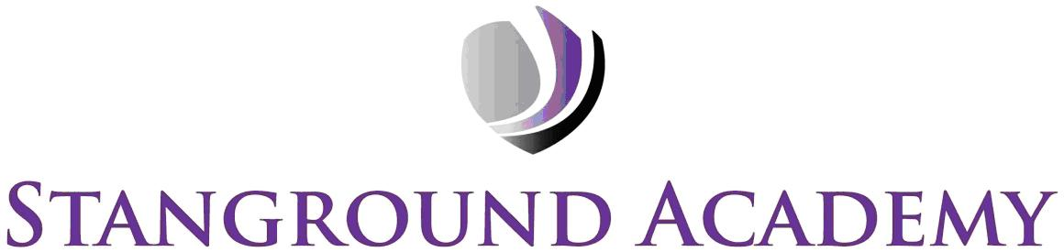

Sixth Form Dress Code
The Stanground Academy dress code for the Sixth Form students embodies our belief that students’ appearance should reflect the smart, professional environment in which they work. As such, students are required to wear ‘business dress’ whilst in the Academy. The Academy defines ‘business dress’ with the following items and associated rules:

Clothing:
- Identification badges with lanyards must always be worn and visible.
- No trainers or canvas shoes.
- Cardigans and jumpers must be smart – not chunky knitwear, or hoodies.
- No Lycra/ elastane, sweatshirt material, denim or leather.
- T-Shirts are not permitted.
- Outdoor coats may be of any style, but should not be worn during lessons or study sessions.

Males:
- Plain, pinstriped or chino trousers.
- A smart professional shirt (i.e. plain, checked, striped).
- Ties are optional – comic patterns are not allowed.

Females:
- Skirts should be of an appropriate length – miniskirts are not allowed.
- Leggings, jeans, leather or leatherette skirts, dresses or trousers are not allowed.
- Heels should be no higher than 5cm. Smart ankle or higher boots may be worn (maximum knee high) .
- UGG boots or Caterpillar style boots must not be worn.
- Tops, shirts or blouses must be smart and professional looking, they must not be strappy or low cut.
- Dresses must adhere to the points regarding skirt length and blouse tops.
- Make-up must be discreet.

Piercings and Hair:
- No facial piercings should be worn; however, a discreet nose stud is acceptable.
- Jewellery should not be excessive.
- Hair must not be worn in an extreme style or colour.

I understand that should my dress be deemed to be in contravention of these rules that I will be asked to go home to change.

Student name: _______________________________________ (Print)

Signed: _____________________________________________ Date: ______________________________

