Sports partnership

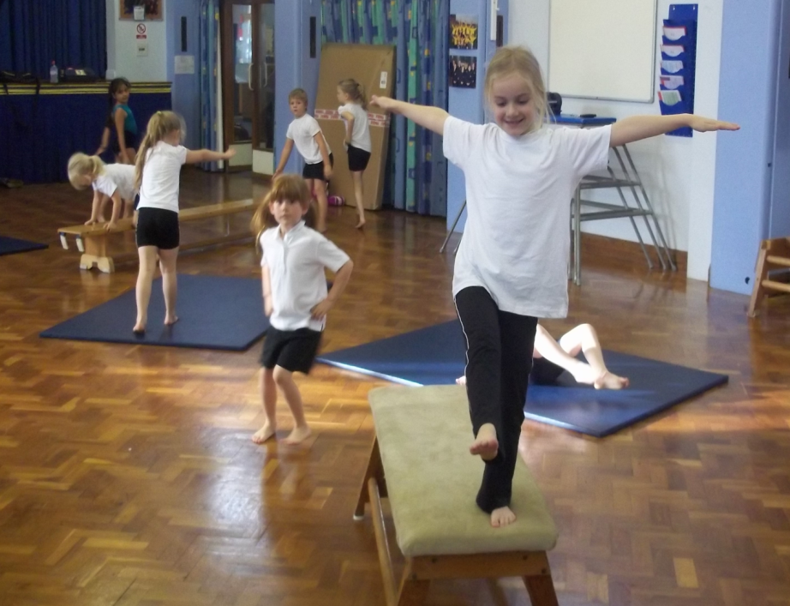

PE and sport premium offer
2017 to 2020

Government - primary school sports funding

The Government have confirmed that income from the soft drink industry levy will be spent on school physical education (PE) and sport provision and breakfast clubs in England.
  - double the primary school PE and sport premium from £160 million per year to £320 million per year from September 2017 to help schools support healthier, more active lifestyles. This funding will enable primary schools to make further improvements to the quality and breadth of PE and sport they offer, such as introducing new activities and after school clubs and making greater use of coaches
  - provide up to £285 million a year to give 25% of secondary schools increased opportunity to extend their school day to offer a wider range of activities for pupils, including more sport
  - provide £10 million funding a year to expand breakfast clubs in up to 1,600 schools starting from September 2017, to ensure more children have a nutritious breakfast as a healthy start to their school day
Purpose of funding:
Schools will have to spend the sport funding on improving their provision of PE and sport, but they will have the freedom to choose how they do this.
Possible uses for the funding include:
- hiring specialist PE teachers or qualified sports coaches to work alongside primary teachers when teaching PE
- engaging with key organisations, eg Greenwood Academies Trust (GAT), Youth Sport Trust (YST) etc
- new or additional Change4Life sport clubs
- paying for professional development opportunities in PE/ sport
- providing cover to release primary teachers for professional development in PE/ sport
- running sport competitions, or increasing participation in the school games
- buying quality assured professional development modules or materials for PE/ sport
- providing places for pupils on after school sport clubs and holiday clubs

Accountability:
Schools are now being held to account for how they spend the sport funding. Ofsted has strengthened its coverage of sport and PE within the Inspectors’ handbook and supporting guidance, so that schools and inspectors now know how sport and PE will be assessed.
The judgment of the effectiveness of sport premium funding sits in the leadership section of the Ofsted report.
During section 5 inspections, inspectors will be asked to assess certain aspects of provision as identified in the subsidiary guidance to the school inspection handbook (September 2013).
From 4 April 2014, schools must publish the following on their websites:
- the amount of funding received and the financial details of how it is spent
- use and impact of sport premium
- curricular provision for PE
- extra-curricular sport programme

Stanground Academy Sports Partnership:
This will enable primary schools to access a wide range of PE and sporting opportunities, thus supporting them to enhance the quality of PE and sports provision within their school. Furthermore, it will enable qualified PE staff to up-skill and support primary staff in the delivery of high quality PE.

Some of the achievements of the Stanground Academy primary programme 2016 to 2017:
- by the end the this academic year 2785 primary students will have attended festivals at the Stanground Academy
- every year group from reception through to year 6 have had inclusive level 2 festivals offered to them at the Stanground Academy
- students have taken part in intra competitions led and supported by Stanground Staff
- created partnerships with 13 primary schools
- offered a diverse range of competitions, events and festivals
- over 64 primary students trained as lunch time play leaders
- supported the development of physical education for primary staff and students
- sustained the partnership both financially and through our commitment to developing sporting opportunities
- worked closely with the school games organiser
- offered and delivered bespoke continued professional development (CPD) for cluster and individual schools requirements
- produced resources to support high quality teaching within the curriculum ranging from OAA and Games
- trained and deployed over 263 students in KS3, KS4 and KS5 to assist with festivals. many of which are ex-students from cluster primary schools
- 296 demonstration lessons lead by the Stanground Academy staff in the first two and half terms.

The Greenwood Academies Trust, through the Stanground Academy, is committed to developing opportunities for young people within the Peterborough area. As a result of the new funding model, we have a fantastic opportunity to build a legacy for PE provision through our offer.

Offer | Benefits
High quality teaching  two hours per week  (30 weeks) | - acts as a CPD vehicle to up-skill primary staff (teaching and support)  - enables students to access a variety of specialist sports and specific areas of sporting expertise  - creative timetabling will allow for the teaching hours to include lunch time and after school clubs  - flexibility to work around a primary school timetable  - use the expertise to advise on PE curriculum, risk assessments, schemes of work and lesson planning
Sports plan membership | - over 12000 sports training games and drills  - favourite the drills you like to save them and find them more easily later  - put drills together to build your own sports coaching plan
Primary PE forum | - three meetings per year, hosted by different schools within the partnership  - a networking opportunity for primary staff to discuss how the provision is working, share areas of best practice and alleviate any concerns  - all staff are updated with partnership developments, new initiatives and programmes
Newsletter | - making everyone aware of fixtures, events, training and best practice  - celebrating success of pupils and schools  - schools will have the opportunity to add to the newsletter, link to literacy, pupil work, photographs and interviews  - potential for each school to write an article to showcase their school
Partnership website | - a link from your school website to our partnership website  - parents can see what sport provision their children are receiving  - this would strongly support the government recommendation that schools will be expected to highlight their PE provision on their school websites
Play leader/ midday supervisor training | - central training is given to Year 5 and 6 students to run activities for the lower key stage playground  - the training will be aimed to encourage positive play and look at the qualities required to become a play leader  - games ideas are shared as well as looking at the structure of the playground and play zones  - support is given to the midday supervisor’s on how to implement the play leader structure and positive play  - regular visits and support from your secondary PE link
Key Stage 1 multi skills central staff training | - up-skill KS1 staff to develop their subject knowledge and confidence to deliver Multi-Skills  - develop PE in its early stages creating a foundation to build on  - lesson plans and resources will be available to help the delivery after the training
School Games Mark accreditation | - support and advice given to schools to meet the accreditation criteria  - school Games gives credibility to the competitions made available to the pupils  - many areas of the accreditation criteria will be fulfilled from joining the partnership  - accreditation from nationally recognised organisations demonstrates the high quality of sport and the PE provision within a school
Intra competitions development | - support to set up a full programme of competitions for each individual school  - includes resources and templates for ease of use  - train primary young leaders to officiate, manage and deliver these events
Inter Stanground Academy festivals | - provide at least one inter-festival per year group in response to cluster needs to be delivered on either a school or club site  - sports will range from multi-skills, swimming gala, sports hall athletics, football, high-5 netball, tri-golf, striking and fielding, dodgeball and a sports day  - provide a competitive competition format that has a direct pathway to the school games.
Resources | - provide free resources to support the delivery of high-quality teaching and learning. For example, gymnastics, swimming, multi-skills, games schemes of works  - free loan of specialist PE/ sport equipment to support high quality teaching and learning with access to a partnership resources library of specialist sports equipment
Sports leaders | - Stanground Academy will provide leaders to support the delivery of your school’s sports day, competitions, events etc.  - GAT leaders have been recognised at a national level for their ability, commitment and enthusiasm (Aviva British Sports Hall Athletics Finals, Birmingham NEC)
Swimming | - opportunity to buy swimming services at the Stanground Academy pool at a reduced rate  - to ensure that year 6 students have the opportunity to reach the swimming standard of 25 meters in a recognised stroke  - through the GAT sports provision, each school will receive a half-term block of swimming for year 6 students led by a fully-qualified level 2 swim teacher and a life guard
Inter school Football and Netball league | - centrally organised football and netball leagues for year 5 and 6 students  - fixtures, results and league tables created by Stanground Academy  - finals day held at Stanground Academy with trophies and medals

Stanground Academy is committed to delivering and supporting local primary schools in developing and up skilling staff to be able to be confident in teaching Physical Education. We are therefore looking for a buy in scheme of 3 academic years to take primary schools through to the end of the Sports Premium funding.
At the end of each year the provision will be reviewed by both Stanground Academy staff and Primary cluster staff. Amendments to cost and content to the provision can be made to make sure it is still effective and fit for purpose in meeting DoE for uses of the Sports Premium funding.
A service level agreement will be issued outlining the work that Stanground Academy will complete.

Primary School PE Sports Offer 2017 to 2020

School name:________________________________________________________
We would like to register our commitment to the Greenwood Academies Trust PE and sport premium offer, through the Stanground Academy 2017 to 2020 for the cost of £5565.

Head teacher’s name:________________________
Signature:__________________________________

Please return to Andrew Phillips, Partnership Development Manager by Friday 16th June 2017.
Stanground Academy
Peterborough Road
Peterborough
PE7 3BY

Tel: 01733 821430 ext 5730
APhillips@stangroundacademy.org

