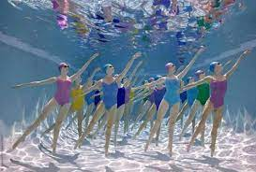
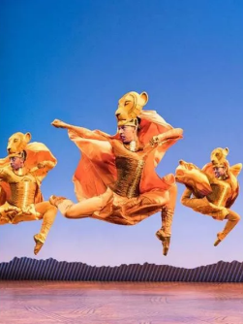
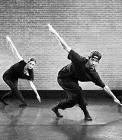
DANCE: Year 7 Knowledge Organiser
Stylistic Features
Baseline  Mobility, aerobic and stretch including isolations, stepping patterns and use of parallel and turn out | Sports Fusion  Phrase 1: Football (House dance); gallop shuffle, jacking, flexion,  Phrase 2: Basketball (hip-hop); Tutting, contraction, pas de bourree  Phrase 3: Swimming (contemporary); Ronde Jambe, Arch, Seat roll | Lion King  Attitude positions, use of relevé and plie, jazz fourth positions, arch and contract, core strength, high jumps and leg extensions.
The elements of dance

Action – Elevation, gesture, turn, travel, stillness
Space – The ‘where’ of movement; levels, directions, pathways, size of action & formation
Dynamics – Degrees of speed, force and flow that creates the quality of the movement
Relationships – The ways in which dancers interact and connect with one another.
Motif – A single movement or short phrase, which has the potential to be developed
Motif development: The adaption, variation and extension of the motif through ASD&R

Different dance styles
- Students will explore contrasting dance styles; contemporary, hip-hip and house
- Students will have the opportunity to learn short phrases in each style and then in a group, create their own compositions
Compositional devices: tools used to develop movement

Unison- Two or more dancers doing the same movement at the same time
Canon- Movement performed at different times, one dancer followed by another
Lead & Follow- One dancer following the pathway of another
Question & Answer- One dancer performs and the other dancer performs a movement that ‘replies’
Repetition- An action or sequence that occurs again
Retrograde- The motif performed backwards, as though rewound
Mirroring- Dancers reflecting movement as a mirror image
Numerical Variation- Grouping dancers (2:2 duet, group 3:1, 6:2)
Pathway- Direction of travel to create spatial designs and patterns
Formation- The spatial positioning of the dancers (lines, circles)
Accumulation- Repeating a phrase with a new movement each time
Fragmentation- The phrase is broken down into smaller parts and reordered
Embellishment- Detail is added to the original movement

Physical skills:

Balance- Arrangement of body parts to create equal distribution of weight
Alignment- Placement of body parts in relation to one another
Strength- Withstand or exert force with muscle power
Isolation- Independent movement of a single body part
Control- Engagement of muscles to start, stop, change direction and hold shape with accuracy
Stamina- Sustain prolonged physical activity requiring muscular and cardio-respiratory endurance
Posture- Carriage of the body and the way in which its held
Extension- The lengthening of limbs
Coordination- Effective combination of movement from various body parts
Flexibility- Range of movement in the joints and the lengthening of muscles across the joints
Mobility- Moving fluently from action to the next

Performance skills:
Projection - Confident presentation of one’s body and energy to communicate movement and meaning
Musicality - The ability to be receptive to rhythm, tempo and mood when dancing.
Energy- Amount of dynamic force and the qualities of the movement
Focus - Use of eyes to enhance performance / where eyes are directed.
Facial Expression – A gesture executed with facial muscles to communicate mood, feeling or character.
Emphasis- The accents in energy and timing provided by the dancer at different moments throughout the dance.
Commitment- The level of dedication to the performance role
Timing- Use of time/counts to match movements to sound.
Spatial awareness - the ability to see objects in relation to each other and to oneself.
Form/Structure: The order in which a dance is put together
Rondo (ABACADA) - ‘A’ is the chorus and is repeated after each different verse.
Ternary (ABA/ABA) - a contrasted middle section where the beginning is either repeated exactly the same or is presented as a modified version.
Binary (AB) - two contrasting sections
Narrative (ABCDEF) – Movement content is sequentially arranged into separate sections; this could be to tell a story.
Theme and variation (A1,A2,A3) – Each section builds and develops from the section before. The theme provides a basis for the variation and each variation becomes the theme for the next variation.

Professional Repertoire: The Lion King
- A fusion of traditional African dance and contemporary technique
- Students will learn some the original repertoire from London’s West End show and take part in a series of choreographic workshops to explore the elements of dance and create their own African Dance to perform in our creative faculty showcase

